 | Chaguaramas Golf Club
Rudder Alexander Open
Friday April 14th  to  Sunday 16th, 2023  Professionals Flight  Championship Flight – max 6.3  1st Flight – 6.4 to 11.2  2nd Flight – 11.3 to 17  3rd Flight – 17.1 to 25  Ladies – Any Handicap  Professionals – 3 days ($1000.00)  Championship and 1st Flight – 3 days ($750.00)  2nd Flight, 3rd Flight and Ladies -2 days ($600.00)  Registration can be done via www.cgc.wildapricot.org/event-5175690  Points earned in this tournament will be applied toward the National Ranking System, which determines eligibility for invitation to the national trials. |  | 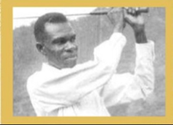  Born in 1908, Fitzroy Rudder was the first black man to become a professional golfer in Trinidad & Tobago. “The Father of Golf” shaped the futures of many aspiring golfers and teaching professionals. He was awarded the Humming Bird Silver Medal for Achievement in 1981.  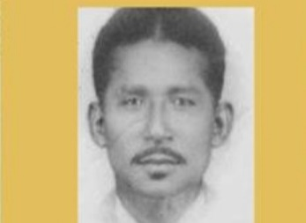  Victor Alexander was born in 1914 in St. James, Trinidad and was a trail blazer in the sport of golf. Alexander designed, constructed and maintained the Point-a-Pierre Golf Course. He was awarded the Humming Bird Silver Medal Achievement in 1999.

